**Nile Rat Plasma Lipidomics Report**

**Objective**

**No. 0138 what number?**16 Aug 2021

**Project Lead:**Katherine A. Overmyer

**Project Contributors:**

Joshua J. Coon

**Collaborators:**

Huishi Toh

Peng Jiang

James Thomson

**Acknowledgement:**

NIH P41 GM108538

Nile rats are a unique model system to explore incidence and biomarkers of diabetes [copied this sentence from Jan 2020 report]. This study aims to determine feasibility of random blood glucose-level sampling versus the standard fasted blood glucose sampling on diabetic Nile rats. The analysis presented here performed liquid chromatograph-mass spectrometry lipidomics on Nile rat plasma samples. Raw data were processed and subjected to preliminary data analysis.

**Results Summary**

**Lipidomics_processed_data.xlsx** contains the output from our LipiDex/Compound Discoverer software workflow. The **Lipidomics Raw Output** sheet of the document contains the raw output from the workflow. The **Lipidomics Filtered** sheet of the document contains the data after filtering steps. Relative standard deviation (RSD) filtering performed based on features with >50% RSD as based on average of QC2 and QC3 files. Features were also filtered based on “Found in at least 4 files” to eliminated likely spurious identifications from few files. Other changes to filtered data include removal of MS quality control files, and addition of a Unique Identifier column for each lipid feature.

**Lipidomics Summary Figures**

**Figure 1:** Boxplots of all features (raw data prior to filtering) per file, given in analytical order left-to-right. Y-axis gives log2 quantitation of features. The boxplots do not show any large deviations from the median, nor any consistent trend in drift, suggesting that the LC-MS runs provided stable quantitation over the runs.

**Figure 2:** Boxplots of triplicate LC-MS runs of randomly chosen plasma sample. QC1 shows depressed average feature quantitation, and was removed from the RSD filtering step.

**Figure 3:** PCA plots. **(A)** PCA of all 10 rats across all 6 weeks (60 samples total) showing separation of RBG vs FBG sample type. **(B)** PCA now colored by rat (10 rats total), with square markers corresponding to FBG, and circles to RBG. **(C)** PCA plot colored by animal, with colored arrow-lines showing progression from week 8 to 9 to 10.

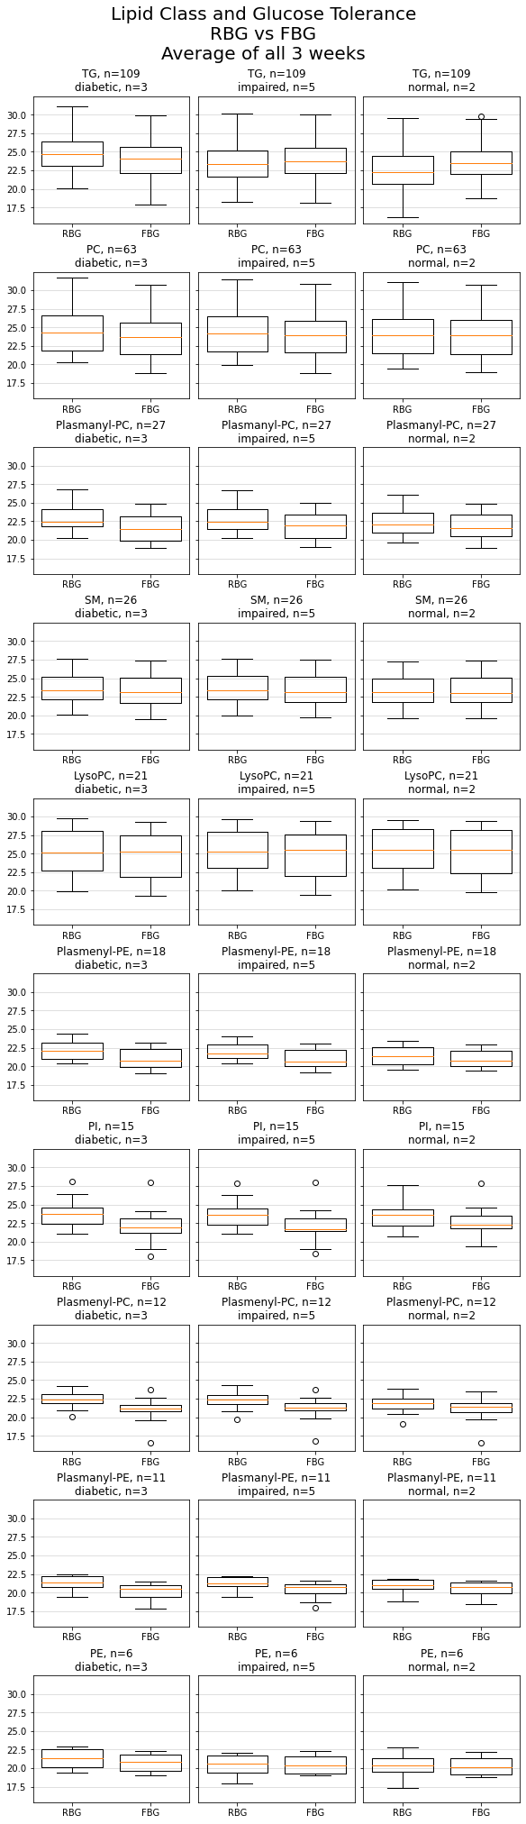

**Figure 4:** Comparing RBG vs. FBG, broken down by glucose tolerance in each rat in columns (n=3 diabetic, n=5 impaired, n=2 normal), and by top 9 most abundant lipid classes identified in samples in each row (abbreviations: TG = triacylglycerol, PC = phosphatidylcholine, SM = sphingomyelin, PE = phosphatidylethanolamine, PI = phosphatidylinositol). Each row maintains same log2 feature quant scale for comparison across lipid classes. Filtered data were used for boxplots.

**Future Plans**

Parties will meet in September to discuss these results and other results shared in the interim. Ben and Katie will perform additional analysis of the LC-MS data in combination with the phenotypic observations of the Nile rats as given in the shared excel document that contains animal weights, FBG/RBG, and post-mortem tissue analysis. Katie aims to complete MS metabolomics experiments prior to next meeting. Ben will continue analyzing raw data and share additional findings with collaborators.

**Sample Preparation**

**Lipidomics sample preparation:**

Plasma samples were removed from freezer and thawed on ice. Each sample was extracted with 500 uL 6:2:2 n-butanol:acetonitrile:water. 100 uL of extract was dried down in SpeedVac evaporator per sample in triplicate, in separate amber autosampler vials. For lipidomics, each extract was resuspended in 50 uL 9:1 MeOH:toluene then analyzed on mass spectrometer.

**LC-MS Analysis**

**LC-MS Lipidomics:**

Sample analysis was performed on an Acquity CSH C18 column held at 50 °C (100 mm x 2.1 mm x 1.7 μm particle size; Waters) using a Vanquish Binary Pump (400 μL/min flow rate; Thermo Scientific). Mobile phase A consisted of 10 mM ammonium acetate in ACN:H2O (70:30, v/v) containing 250 μL/L acetic acid. Mobile phase B consisted of 10 mM ammonium acetate in IPA:ACN (90:10, v/v) with the same additives. Mobile phase B was initially held at 2% for 2 min and then increased to 30% over 3 min. Mobile phase B was further increased to 50% over 1 min, then raised to 85% over 14 min, and finally raised to 99% over 1 min and held at 99 % for 7 min. The column was re-equilibrated with mobile phase B at 2% for 1.75 min before the next injection. 10 µL of extract was injected by a Vanquish Split Sampler HT autosampler (Thermo Scientific).

The LC system was coupled to a Q Exactive HF Orbitrap mass spectrometer through a heated electrospray ionization (HESI II) source (Thermo Scientific). Source conditions were as follow: HESI II and capillary temperature at 300 °C, sheath gas flow rate at 25 units, aux gas flow rate at 15 units, sweep gas flow rate at 5 units, spray voltage at |3.5 kV| for both positive and negative modes, and S-lens RF at 90.0 units. The MS was operated in a polarity switching mode acquiring positive and negative full MS and MS2 spectra (Top2) within the same injection. Acquisition parameters for full MS scans in both modes were 17,500 resolution, 1 × 106 automatic gain control (AGC) target, 100 ms ion accumulation time (max IT), and 200 to 1600 m/z scan range. MS2 scans in both modes were then performed at 17,500 resolution, 1 × 105 AGC target, 50 ms max IT, 1.0 m/z isolation window, stepped normalized collision energy (NCE) at 20, 30, 40, and a 10.0 s dynamic exclusion.

**Data Analysis**

**LC-MS Lipidomics:**

The resulting LC–MS data were processed using Compound Discoverer 3.1 (Thermo Scientific) in conjunction with LipiDex (1). All peaks with a 0.4 min to 23 min retention time and 100 Da to 5000 Da MS 1 precursor mass were aggregated into distinct chromatographic profiles (i.e., compound groups) using a 10-ppm mass and 0.2 min retention time tolerance. Profiles not reaching a minimum peak intensity of 5x105, a maximum peak-width of 0.25 min, a signal-to-noise (S/N) ratio of 1.5, and a 3-fold intensity increase over blanks were excluded from further processing. MS/MS spectra were searched against an in silico generated lipid spectral library comprising 35,000 unique molecular compositions from 48 lipid classes. Spectral matches with a dot product score greater than 500 and a reverse dot product score greater than 700 were retained for further analysis. Lipid MS/MS spectra which contained no significant interference (<75 %) from co-eluting isobaric lipids, eluted within a 3.5 median absolute retention time deviation (M.A.D. RT) of each other, and found within at least 2 processed files were then identified at the individual fatty acid substituent level of structural resolution. If individual fatty acid substituents were unresolved, then identifications were made with the sum of the fatty acid substituents.

**References**

(1) Hutchins PJ, Russell JD, Coon JJ. LipiDex: An Integrated Software Package for High-Confidence Lipid Identification. *Cell Systems* **6**, 1-5 (2018). <https://doi.org/10.1016/j.cels.2018.03.011>

**Figures**